**PESTEL Analysis**

Report for Human Resources

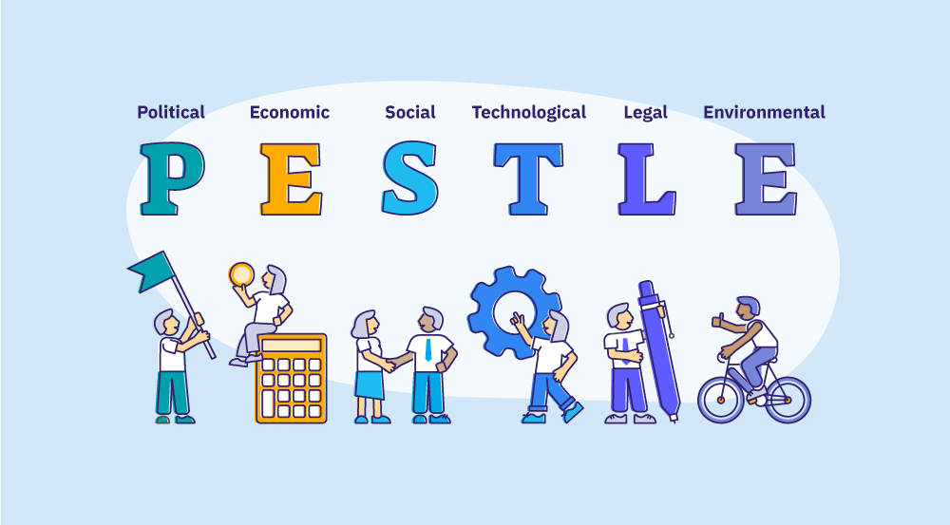

**Data Driven Decision Making**



**Data Dynamos**

For HR Data Analysis

**PESTEL Analysis Report for Human Resources**

**1. Political Factors:**

* The potential impact of government policies on labor laws, such as minimum wages and social insurance.
* Stability in tax policies can affect salary costs and benefits.
* Any legal changes related to leave policies and flexible work arrangements may impact hiring strategies.
* Government initiatives to promote employment, such as tax incentives for hiring new employees, may create opportunities.
* Labor union influence and potential strikes could impact workforce stability and wage negotiations.

**2. Economic Factors:**

* The average monthly salary of employees is **$ 337,508**, with a minimum of **$ 61,607** and a maximum of **$ 1,575,757**, reflecting disparities in salary levels.
* The total monthly payroll amounts to **$ 13,837,171**, constituting a major operational cost.

 

 

* The employee turnover rate of **15%** highlights the need for better talent retention strategies.
* Inflation and exchange rates may affect employees' purchasing power, potentially leading to salary increase demands.
* Economic growth and industry trends may influence the company's ability to expand and attract top talent.
* Unemployment rates in the market could impact the availability of skilled labor.

**3. Social Factors:**

* **92%** of employees are covered by health insurance, enhancing workplace satisfaction.
* Only **8%** of employees have low performance, aligning with the percentage of uninsured individuals in the United States and reflecting a generally high level of efficiency.
* Only **8%** of employees have low performance, indicating a high level of efficiency.
* The average annual leave per employee is **20 days**, contributing to work-life balance.
* In the United States, there is no federal law requiring employers to provide paid annual leave, making it one of the few countries that do not guarantee this right by law. However, many employers offer paid leave as part of their benefits package to attract and retain employees. According to available data, the average American employee receives approximately **10 days of paid annual leave** after one year of service, in addition to **10 days of public holidays**, bringing the total to around **20 days of paid leave per year**. Based on this, the **average annual leave per employee is 20 days**, contributing to work-life balance.
* The total number of sick leave days during the year varies in days but is not specified according to cities and company regulations, which may require strategies to enhance employee well-being and reduce absenteeism.
* Changing workforce demographics, such as increasing demand for diversity and inclusion initiatives, may impact hiring and HR policies.
* Employee expectations for flexible working arrangements and career development opportunities are growing.
* In the United States, there is no federal law requiring employers to provide paid sick leave. However, some states and cities have enacted specific laws to ensure employees' rights to paid sick leave**. For example:**

**New York City:** Employees are entitled to one hour of paid sick leave for every 30 hours worked, with the ability to accumulate up **to 40 or 56 hours per year**, depending on the size of the employer.



**4. Technological Factors:**

* The implementation of **528 training courses** during the year, involving **1470 employees**, reflects an investment in professional development.
* The use of data analysis tools like **Power BI** & **Tableau** contributes to better decision-making.
* There is a need to adopt more digital systems to automate HR processes and enhance efficiency.
* Advancements in AI and automation may impact workforce requirements and training needs.
* Cybersecurity concerns are growing, requiring enhanced data protection measures for employee information.
* The increasing use of remote work technologies is reshaping HR management practices.

**5. Environmental Factors:**

* The potential for adopting sustainable practices in the workplace, such as reducing paper and energy consumption.
* Daily commuting for employees may pose an environmental burden, encouraging consideration of remote work policies.
* New environmental regulations may require updates to office management policies.
* The company may benefit from corporate social responsibility (CSR) initiatives that promote sustainability.
* Climate change and environmental risks could impact operational costs, such as energy and transportation expenses.
* Waste management policies and eco-friendly initiatives can improve the company's environmental footprint.

**6. Legal Factors:**

* The company's commitment to **92%** health insurance coverage demonstrates compliance with employee welfare regulations.
* The majority of the population in the United States has health insurance coverage, with more than half receiving private health insurance through their jobs. However, approximately 8% of the population remains uninsured. These figures indicate that the U.S. healthcare system relies heavily on employer-sponsored private insurance, with challenges in achieving comprehensive coverage for all residents.
* Adhering to labor laws concerning working hours and leave policies is essential to avoid legal risks.
* Regularly reviewing employment contracts ensures compliance with any new legal updates.
* Changes in labor regulations regarding employee benefits, pensions, and termination policies may impact HR strategies.
* Intellectual property laws and data protection regulations require compliance in handling employee records.
* Anti-discrimination and workplace harassment laws necessitate continuous HR policy updates and employee training.

**Recommendations:**

1. Strengthen talent retention strategies to reduce employee turnover.
2. Invest in automation and digital technology to improve process efficiency.
3. Develop employee wellness programs to reduce absenteeism.
4. Enhance flexible work policies to reduce environmental impact and increase employee satisfaction.
5. Monitor inflation effects on salaries to maintain market competitiveness.
6. Conduct periodic legal compliance reviews to avoid any legal violations.
7. Implement corporate sustainability initiatives to align with environmental regulations.
8. Leverage AI and technology to enhance training and workforce productivity.
9. Develop diversity and inclusion programs to attract a broader talent pool.
10. Strengthen cybersecurity measures to protect employee data and HR systems.

**Conclusion:**

 The PESTEL analysis highlights the opportunities and challenges faced by HR management. By implementing the proposed recommendations, the company can improve the work environment, increase efficiency, and promote sustainability. A strategic approach to adapting to external factors will ensure long-term success and workforce stability.

|  |
| --- |
| **Data Dynamos** |